SP-104-AIML Active Learning Management

CS 4850 – Fall 2025

August 28, 2025

|  |  |  |  |
| --- | --- | --- | --- |
| A person in a checkered shirt  AI-generated content may be incorrect.  Josh Smith  Team Leader  Developer | A person in a suit and bow tie  AI-generated content may be incorrect.  Elijah Merrill  Developer | A person with long hair wearing a black shirt  AI-generated content may be incorrect.  Noah Lane  Documentation | A person in a suit and tie  AI-generated content may be incorrect.  Matthew Hall  Documentation |

**Team Members:**

|  |  |  |
| --- | --- | --- |
| Name | Role | Cell / Alt Email |
| Josh Smith (Team Lead) | Developer | 706-414-2827  joshuasmith0515@gmail.com |
| Elijah Merrill | Developer | 478-283-0811  elijahmerrill04@gmail.com |
| Matthew Hall | Documentation | 678-873-8542  thematthewhall7@gmail.com |
| Noah Lane | Documentation | 706-591-2312  noahlane142@gmail.com |
| Sharon Perry | Advisor | 770-329-3895  sperry46@kennesaw.edu |

**Project Overview**

We aim to create a program that is intelligent enough to be an image labeling system using an active learning loop to efficiently interpret satellite imagery. The core objective is to minimize human labeling efforts while trying to achieve decent classification accuracy. By integrating an active learning system with uncertain sampling, the system selectively acquires the most informative images for labeling. The system will use tools like Python, mainly for the use of its libraries to help build an active learning framework, Kaggle for datasets, and Azure for testing large taxing runs due to high input of images.

**Project Website**

The current plan for our website domain is “theworldfromabove.org” but could be changed as we progress through the project.

**Deliverables**

* Team/Project Selection document (Individual Assignment)
* Weekly Activity Reports (WARs – Individual Assignment)
* Team Status Report (TSR – Group Assignment)
* Peer Reviews (Individual Assignment)
* Project Plan (Group Assignment)
* SRS, SDD, STP & Dev Doc (Group Assignment)
* Prototype Presentation for Peer Review (Group Assignment)
* Final Report Package (Group Assignment)
  + Final Report (Group Assignment)
  + Source Code (Group Assignment)
  + Website (Group Assignment)
  + Video Demo (Group Assignment)
  + Web App or Notebook (Group Assignment)
  + Labeled Dataset (Group Assignment)
  + Learning Curve Analysis (Group Assignment)
* C-Day Application/Submission

**Group Meeting Schedule**

* 7 pm every Wednesday
* Sundays when necessary or appropriate
* Flexible according to the different schedules of all group members

**Collaboration and Communication Plan**

**Microsoft Teams:** For status meetings and weekly/bi-weekly group meetings

**Discord/GroupMe:** For communication, brainstorming, and information sharing

**Project Schedule and Task Planning**

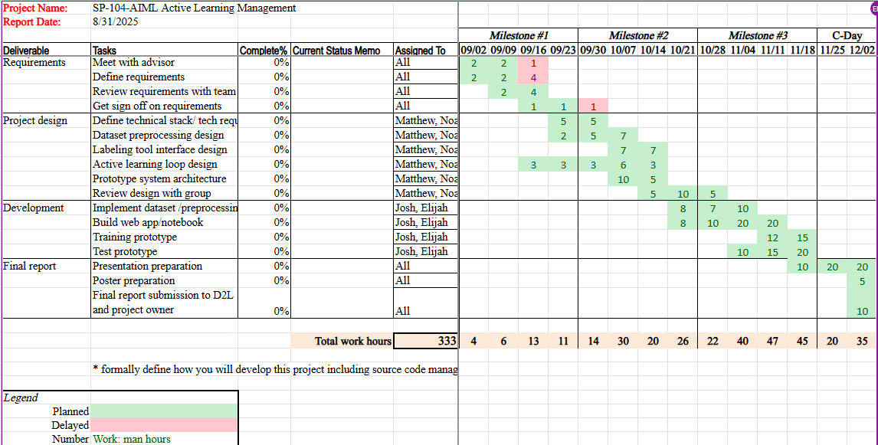

* *All tasks and hours committed are estimated and subject to change as of the creation of this document.*

**Version Control Plan**

Update releases of learning model/source code periodically through a group GitHub account.

<https://github.com/ksusp104>